**Jibo**

[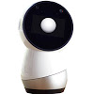](https://en.wikipedia.org/wiki/File:JiboTheRobot.jpg)

A white variant. Jibo also came in black.

On July 16, 2014, Breazeal launched an [Indiegogo](https://en.wikipedia.org/wiki/Indiegogo) campaign to crowdfund the development of ***Jibo***, a personal assistant robot widely marketed as the world's first family robot.[[16]](https://en.wikipedia.org/wiki/Cynthia_Breazeal#cite_note-16) She served as chief scientist and chief experience officer.[[3]](https://en.wikipedia.org/wiki/Cynthia_Breazeal#cite_note-media.mit.edu-3) Jibo [[17]](https://en.wikipedia.org/wiki/Cynthia_Breazeal#cite_note-17) reached its initial fund-raising goal and was due to launch in 2015, then later pushed to 2016,[[18]](https://en.wikipedia.org/wiki/Cynthia_Breazeal#cite_note-18) before finally being released in November 2017.[[19]](https://en.wikipedia.org/wiki/Cynthia_Breazeal#cite_note-19) The robot was created with the goal of creating more engaging social experiences, including storytelling and other forms of entertainment.

Jibo generally received poor reviews, being compared to the more powerful and much cheaper Amazon Alexa and Google Home.[[20]](https://en.wikipedia.org/wiki/Cynthia_Breazeal#cite_note-20)[[21]](https://en.wikipedia.org/wiki/Cynthia_Breazeal#cite_note-21)[[22]](https://en.wikipedia.org/wiki/Cynthia_Breazeal#cite_note-22) The [software development kit](https://en.wikipedia.org/wiki/Software_development_kit) expected for developers was never released.[[23]](https://en.wikipedia.org/wiki/Cynthia_Breazeal#cite_note-23) On December 15, 2017 the company announced layoffs[[24]](https://en.wikipedia.org/wiki/Cynthia_Breazeal#cite_note-24) and shut its doors soon after. By the time Jibo shut down, **it had raised more than $70 million**.[[25]](https://en.wikipedia.org/wiki/Cynthia_Breazeal#cite_note-25) Breazeal has made no public comments in regard to the closing of Jibo.[[26]](https://en.wikipedia.org/wiki/Cynthia_Breazeal#cite_note-26) In March 2020, the assets for Jibo Inc. were acquired by [NTT Corporation](https://en.wikipedia.org/wiki/Nippon_Telegraph_and_Telephone). [NTT Disruption](https://en.wikipedia.org/w/index.php?title=NTT_Disruption&action=edit&redlink=1) intends to bring Jibo to the healthcare and education markets.[[27]](https://en.wikipedia.org/wiki/Cynthia_Breazeal#cite_note-27)

# **Jibo social robot: where things went wrong**

**By [Oliver Mitchell](https://www.therobotreport.com/author/omitchell/) | June 28, 2018**

**[Facebook](https://www.therobotreport.com/#facebook)[Twitter](https://www.therobotreport.com/#twitter)[LinkedIn](https://www.therobotreport.com/#linkedin)[Reddit](https://www.therobotreport.com/#reddit)[Pinterest](https://www.therobotreport.com/#pinterest)[Share](https://www.addtoany.com/share#url=https%3A%2F%2Fwww.therobotreport.com%2Fjibo-social-robot-analyzing-what-went-wrong%2F&title=Jibo%20social%20robot%3A%20where%20things%20went%20wrong)**

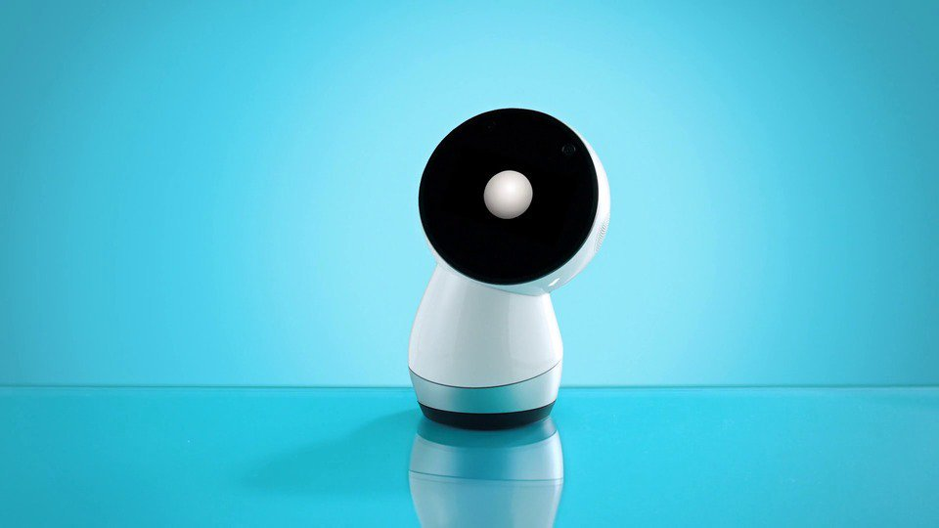

*Jibo social robot*

Social robot company **[Jibo](http://www.jibo.com/)** is sadly running on fumes after burning through nearly $73 million in funding. In a story first reported by **[BostInno](https://www.americaninno.com/boston/inno-news-boston/more-layoffs-hit-jibo-this-time-theyre-significant/)** and since confirmed by *The Robot Report*, Jibo has laid off the majority of its workforce to enable “additional time to secure additional funding or pursue an exit.”

Jibo was once heralded as “the first social robot for the home.” Founded in 2012 by famed MIT roboticist Cynthia Breazeal, Jibo successfully raised over $3.5 million when its Indiegogo campaign ended in 2014. At the time, Breazeal promised to usher in a new age of social robotics.

“The way that the personal robots revolution is going to really happen is by making it a platform. Because once you do that, suddenly you can have a robot that can do many things for you, for many different people, versus these niche robots that only vacuum or only clean your gutter.”

In Breazeal’s mind, Jibo was indeed that platform. Jibo was even recently endorsed by *Time Magazine* as one of the best innovations of 2017.

There are many exciting things happening in robotics, but Jibo is the latest reminder that most of the innovation is taking place outside the consumer market. Other than a few robot vacuum companies, mainly iRobot, no company has developed a successful home robot. And the list of companies that have tried includes Honda, SoftBank, Sony (Japan Times reporting Sony has sold more than 11,000 units on its new Aibo robot dog), Samsung, Toyota, all of which have tremendous financial and engineering resources. Even iRobot’s success is pretty limited when compared to a consumer device like the iPhone, which sold 40.6 million units in the first quarter of 2018 alone.

*The Robot Report* reached out to Jibo multiple times, but we have not heard back. Where did things go wrong for Jibo?

**1. A series of delayed shipments**The first indication of Jibo’s problems were a **[series of delayed shipments](https://www.therobotreport.com/as-ford-sets-a-date-jibo-retracts-theirs/)**, forcing Indiegogo a year ago to offer full refunds for unfulfilled orders. In September 2017, Jibo started shipping its first units. However, the product reviews were less than stellar. Jibo began selling to the general public in October 2017 with a price tag of $899.

**2. Cancelling international orders**  
After initially taking international orders, Jibo in mid-2016 cancelled orders overseas. It said it would only ship robots to customers in the US and Canada. “After exploring all the options, we have come to the conclusion that we will not be able to deliver Jibo to your country” because the robot “won’t function up to our standards in your country.”

International orders add layer upon layer of localization issues: electrical certifications, language, speech recognition, cultural nuances, etc. Jibo’s solution to these mounting problems was to cancel all international orders and endure the disappointment of customers in the 45 countries involved.

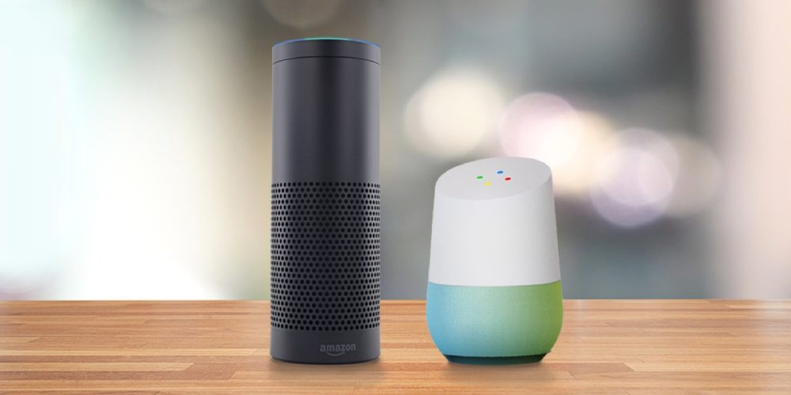

*Amazon Echo (left) and Google Home.*

**3. Cheaper, more skilled competition**  
Soon after Breazeal successfully launched the Indiegogo campaign, Amazon unveiled Echo and priced it seventy-five percent less than Jibo. Almost simultaneously, the e-commerce behemoth announced The Alexa Fund, a $100 million investment vehicle “to fuel voice technology innovation for developers, device-makers, and companies.”

Instead of pivoting in 2015 to meet the new demands of the changing landscape, which eventually became more competitive with Apple and Google joining the fray, Jibo’s Indiegogo commitments became an albatross over the company. In the end, the robot that eventually shipped for close to $1,000, and was merchandised next to a series of more functional machines priced under $100.

It’s unclear exactly what percentage, but a chunk of Jibo’s cost is tied up in its three-axis motor system that allows it to spin 360 degrees. Before the layoffs, a former Jibo employee told *The Robot Report*that Jibo was exploring the idea of downgrading the motor system. To compensate for its non-human appearance, Jibo over-engineered the robot’s motion to make it seem more human. The thought was that lessening the motor system might not have a major impact on the robot’s performance while significantly cutting costs.

**4. Jibo knockoffs**

One major issue with crowdfunding campaigns is that companies essentially are revealing their product plans before they’re ready. And in Jibo’s case, well before they’re ready. **[Jibo knockoffs starting popping up](https://www.therobotreport.com/jibo-look-alike-appears-on-chinese-websites/)** in China in late 2016, and there was a slew of Jibo knockoffs at CES 2017. And soon there after the floodgates opened to other consumer companies introducing Jibo-like competitors.

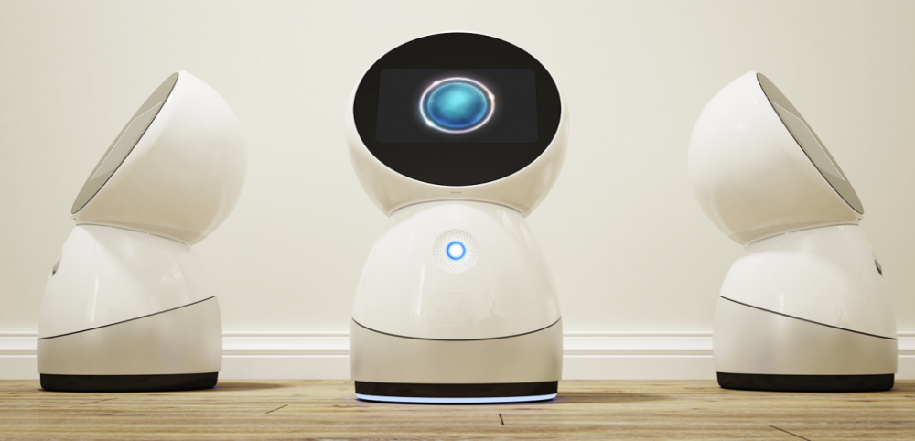

*Oding’s Chinese knockoff of Jibo first appeared in late 2016.*

## Jibo another crowdfunding casualty

When analyzing the success of crowdfunding projects, analysts often cite a **[2015 study](https://www.kickstarter.com/fulfillment)** by the University of Pennsylvania that surveyed more than 500,000 online financial backers of Kickstarter projects. According to the report, “project backers should expect a failure rate of around 1-in-10 projects, and to receive a refund 13 percent of the time. Since failure can happen to anyone, creators need to consider, and plan for, the ways in which they will work with backers in the event a project fails, keeping lines of communication open and explaining how the money was spent. Ultimately, there does not seem to be a systematic problem associated with failure (or fraud) on Kickstarter, and the vast majority of projects do seem to deliver.”

This research was conducted before such high-profile fraud cases as the $179 million campaign by Star Citizen, $35 million **[scam by Lily Drone](https://www.therobotreport.com/parrot-struggling-lily-fails-and-google-closes-titan-project-as-drone-industry-disunites/)**, $17 million by Elio Motors Scooter, and Coolest Cooler’s $13 million fiasco. While more than half of crowdfunding projects never successfully receive funding, it is surprising how many do and never ship, including a grab-bag of very peculiar projects like underwater breathing tubes, anti-radiation underwear, edible drinking cups, and (my favorite) the ostrich pillow.

In response to the growing number of dissatisfied backers that never receive shipments, both Indiegogo and Kickstarter have partnered with product sourcing firms to provide fulfillment services to their funded projects. Last month, Julio Terra of Kickstarter explained to Digital Trends, “The reason why we partnered with Avnet and Dragon Innovation is that we wanted to help creators better prepare for manufacturing before they launch a project on Kickstarter.”

Terra continued, “What we’ve learned over the years is that project problems are often recognized after a product is funded, and at that point, it’s often too late to solve the problem because it’s an issue that was caused by decisions that were made very early on in the process.”

## Social robots aren’t dead

With all that said, social robots aren’t dead. Unfortunately, the technology Jibo requires to be compelling at an affordable price isn’t ready. The company underestimated the its competition and what it would take to get the product off the ground.

Jibo won’t be the product that sparks the social robotics market, Intuition Robotics (ElliQ), Mayfield Robotics (Kuri), Norby (Australia) and others are hoping to do so. Will they be successful or suffer the same fate as Jibo? Only time will tell.

But in contrast to Jibo, Intuition Robotics, for example, will begin commercially marketing ElliQ to geriatric homes later in 2018. Rather than following the Indiegogo route, the Israeli company implemented beta trials with seniors in Florida and California.

# Cynthia Breazeal

|  |
| --- |
| **Cynthia Breazeal** |
| Breazeal in 2017 |

|  |  |
| --- | --- |
| **Born** | November 15, 1967 (age 54)  Albuquerque, New Mexico, US |
| **Nationality** | American |
| **Alma mater** | University of California, Santa Barbara (B.S., EECS, 1989) MIT (S.M., 1993; Sc.D., 2000) |
| **Known for** | Robotics, Jibo, and K-12 AI literacy |

|  |
| --- |
| **Scientific career** |

|  |  |
| --- | --- |
| **Fields** | [Computer science](https://en.wikipedia.org/wiki/Computer_science), [robotics](https://en.wikipedia.org/wiki/Robotics) |
| **[Doctoral advisor](https://en.wikipedia.org/wiki/Doctoral_advisor)** | [Rodney Brooks](https://en.wikipedia.org/wiki/Rodney_Brooks) |

**Cynthia Breazeal** is an American [roboticist](https://en.wikipedia.org/wiki/Robotics) and entrepreneur. She is a former chief scientist and [chief experience officer](https://en.wikipedia.org/wiki/Chief_experience_officer) of Jibo, a company she co-founded in 2012. Jibo produced commercial social robots to be used at home.

## **Early life and education**

Breazeal was born in [Albuquerque, New Mexico](https://en.wikipedia.org/wiki/Albuquerque,_New_Mexico), on November 15, 1967. Her passion for robotics and artificial intelligence was sparked by the designs and robotics in the popular motion picture, *[Star Wars](https://en.wikipedia.org/wiki/Star_Wars)*, when she watched it for the first time at 10 years old.

As the daughter of two scientists, she had early access to the fields of computer science and engineering which helped her fascination turn into a profession. Under the guidance of her parents, Breazeal earned a [B.S.](https://en.wikipedia.org/wiki/Bachelor_of_Science) in electrical and computer engineering from the [University of California](https://en.wikipedia.org/wiki/University_of_California), [Santa Barbara](https://en.wikipedia.org/wiki/Santa_Barbara,_California), in 1989, her [M.S.](https://en.wikipedia.org/wiki/Master_of_Science) in 1993, and her [Sc.D.](https://en.wikipedia.org/wiki/Doctor_of_Science) in 2000 in electrical engineering and computer science, both from [MIT](https://en.wikipedia.org/wiki/Massachusetts_Institute_of_Technology). She had an epiphany watching a NASA robot, and decided to switch her focus to social robotics.

She developed the Kismet robot as a doctoral thesis under [Rodney Brooks](https://en.wikipedia.org/wiki/Rodney_Brooks), looking into expressive social exchange between humans and humanoid robots. Kismet, as well as other robots Breazeal co-developed while a graduate student at the [MIT Artificial Intelligence Lab](https://en.wikipedia.org/wiki/MIT_Artificial_Intelligence_Lab), can now be seen at the [MIT Museum](https://en.wikipedia.org/wiki/MIT_Museum). Notable examples include the upper torso humanoid robot, Cog and the insect-like robot, Hannibal. She also worked on Leonard, Aida, Autom and Huggable. This was early in 2000s, which was long before [Siri](https://en.wikipedia.org/wiki/Siri) and [Alexa](https://en.wikipedia.org/wiki/Amazon_Alexa) existed.

## **MIT career**

Breazeal is a professor of media arts and sciences at MIT, where she founded the Personal Robotics group at the Media Lab.[[1]](https://en.wikipedia.org/wiki/Cynthia_Breazeal#cite_note-1) She has written several books in the field of robotics and has published several peer-reviewed articles on the topic. She also serves on several editorial boards for autonomous and other robotic committees.[[2]](https://en.wikipedia.org/wiki/Cynthia_Breazeal#cite_note-2) The issues she found growing up and studying in university was that robots much too often only interacted with other objects and not people. In addition to this, Breazeal found that if we gave robots the ability to perform non-verbal cues, such as those that humans inherently do everyday, then humans will treat and see robots more like companions and like other humans. She also explored the idea of using robots to build better connections between humans, such as humans who live a long distance away from each other. This way new types of relationships can be fostered that weren't possible beforehand.

Breazeal is also the associate director for the Bridge: MIT Quest for Intelligence where she works on implementing AI through grade school.

Breazeal has centered her work around the concept of "living with AI"[[3]](https://en.wikipedia.org/wiki/Cynthia_Breazeal#cite_note-media.mit.edu-3) which studies the impact of including social robots into our everyday lives. The purpose of adding sentiment to AI would be to offer support to people and to create companionship and support in places where there may be none.

## **Research**

[Leonardo](https://en.wikipedia.org/wiki/Leonardo_(robot)) was one of her earliest robots, co-developed with Stan Winston Studio and a successor to [Kismet](https://en.wikipedia.org/wiki/Kismet_(robot)) (recognized in 2006 by *[Wired](https://en.wikipedia.org/wiki/Wired_(magazine))* magazine as one of the "50 Best Robots Ever").[[4]](https://en.wikipedia.org/wiki/Cynthia_Breazeal#cite_note-4) Leonardo was also used to investigate social cognition and [theory of mind](https://en.wikipedia.org/wiki/Theory_of_mind) abilities on robots with application to human-robot collaboration, in addition to developing social learning abilities for robots such as imitation, tutelage, and social referencing. Nexi,[[5]](https://en.wikipedia.org/wiki/Cynthia_Breazeal#cite_note-5) is another of Breazeal's robots in this tradition, and was named by *[Time](https://en.wikipedia.org/wiki/Time_(magazine))* magazine as one of the 50 Best Inventions of 2008.[[6]](https://en.wikipedia.org/wiki/Cynthia_Breazeal#cite_note-Time-6) Nexi is a MDS robot (mobile, dexterous, social) that combines rich social communication abilities with mobile dexterity to investigate more complex forms of human-robot teaming.

Other social robots developed in Breazeal's Personal Robots group include Autom,[[7]](https://en.wikipedia.org/wiki/Cynthia_Breazeal#cite_note-7) a robot diet and exercise coach (the PhD thesis of Cory Kidd).[[8]](https://en.wikipedia.org/wiki/Cynthia_Breazeal#cite_note-8) It was found to be more effective than a computer counterpart in sustaining engagement and building trust and a working alliance with users. Autom was the predecessor of Mabu (Catalia Health). Breazeal's group has also explored expressive remote presence robots such as MeBot.[[9]](https://en.wikipedia.org/wiki/Cynthia_Breazeal#cite_note-9) The physical social embodiment of the MeBot was found to elicit greater psychological involvement, engagement, and desire to cooperate over purely screen-based video conferencing or a mobile screen. The Huggable was designed as a pediatric companion to help support the emotional needs of hospitalized children and to help support and augment child life specialists.[[10]](https://en.wikipedia.org/wiki/Cynthia_Breazeal#cite_note-10)

Breazeal's Personal Robots group has also done a number of design projects. [Cyberflora](https://en.wikipedia.org/wiki/Cyberflora) was exhibited at the 2003 National Design Triennial[[11]](https://en.wikipedia.org/wiki/Cynthia_Breazeal#cite_note-11) at the Smithsonian [Cooper-Hewitt National Design Museum](https://en.wikipedia.org/wiki/Cooper_Hewitt,_Smithsonian_Design_Museum).

She served as a consultant on the 2001 Spielberg-Kubric movie *[A.I. Artificial Intelligence](https://en.wikipedia.org/w/index.php?title=A.I._Artificial_Intelligence_(film)&action=edit&redlink=1)*.[[12]](https://en.wikipedia.org/wiki/Cynthia_Breazeal#cite_note-12) She also has a prominent role as a virtual participant in a popular exhibit on robots with the traveling exhibit, [Star Wars: Where Science Meets Imagination](https://en.wikipedia.org/wiki/Star_Wars:_Where_Science_Meets_Imagination), interacting with a real [C-3PO](https://en.wikipedia.org/wiki/C-3PO) (voiced by [Anthony Daniels](https://en.wikipedia.org/wiki/Anthony_Daniels)) as she spoke to the audience through a pre-recorded message displayed on a large plasma flat-screen display.

In 2003, she was named by the [MIT](https://en.wikipedia.org/wiki/Massachusetts_Institute_of_Technology) *[Technology Review](https://en.wikipedia.org/wiki/Technology_Review)* [TR100](https://en.wikipedia.org/wiki/TR35) as one of the top 100 innovators in the world under the age of thirty-five.[[13]](https://en.wikipedia.org/wiki/Cynthia_Breazeal#cite_note-13)

In 2020, she was elected a AAAI Fellow by the Association for the Advancement of Artificial Intelligence.[[14]](https://en.wikipedia.org/wiki/Cynthia_Breazeal#cite_note-14)

In March 2020, during the SARS-CoV2 pandemic, Breazeal and her team launched a site with over 60 activities, so students can get access to STEM activities from the lockdown to help teachers and parents continue education from home.[[15]](https://en.wikipedia.org/wiki/Cynthia_Breazeal#cite_note-15)

## **Jibo**

[](https://en.wikipedia.org/wiki/File:JiboTheRobot.jpg)

A white variant. Jibo also came in black.

On July 16, 2014, Breazeal launched an [Indiegogo](https://en.wikipedia.org/wiki/Indiegogo) campaign to crowdfund the development of ***Jibo***, a personal assistant robot widely marketed as the world's first family robot.[[16]](https://en.wikipedia.org/wiki/Cynthia_Breazeal#cite_note-16) She served as chief scientist and chief experience officer.[[3]](https://en.wikipedia.org/wiki/Cynthia_Breazeal#cite_note-media.mit.edu-3) Jibo [[17]](https://en.wikipedia.org/wiki/Cynthia_Breazeal#cite_note-17) reached its initial fund-raising goal and was due to launch in 2015, then later pushed to 2016,[[18]](https://en.wikipedia.org/wiki/Cynthia_Breazeal#cite_note-18) before finally being released in November 2017.[[19]](https://en.wikipedia.org/wiki/Cynthia_Breazeal#cite_note-19) The robot was created with the goal of creating more engaging social experiences, including storytelling and other forms of entertainment.

Jibo generally received poor reviews, being compared to the more powerful and much cheaper Amazon Alexa and Google Home.[[20]](https://en.wikipedia.org/wiki/Cynthia_Breazeal#cite_note-20)[[21]](https://en.wikipedia.org/wiki/Cynthia_Breazeal#cite_note-21)[[22]](https://en.wikipedia.org/wiki/Cynthia_Breazeal#cite_note-22) The [software development kit](https://en.wikipedia.org/wiki/Software_development_kit) expected for developers was never released.[[23]](https://en.wikipedia.org/wiki/Cynthia_Breazeal#cite_note-23) On December 15, 2017 the company announced layoffs[[24]](https://en.wikipedia.org/wiki/Cynthia_Breazeal#cite_note-24) and shut its doors soon after. By the time Jibo shut down, it had raised more than $70 million.[[25]](https://en.wikipedia.org/wiki/Cynthia_Breazeal#cite_note-25) Breazeal has made no public comments in regard to the closing of Jibo.[[26]](https://en.wikipedia.org/wiki/Cynthia_Breazeal#cite_note-26) In March 2020, the assets for Jibo Inc. were acquired by [NTT Corporation](https://en.wikipedia.org/wiki/Nippon_Telegraph_and_Telephone). [NTT Disruption](https://en.wikipedia.org/w/index.php?title=NTT_Disruption&action=edit&redlink=1) intends to bring Jibo to the healthcare and education markets.[[27]](https://en.wikipedia.org/wiki/Cynthia_Breazeal#cite_note-27)

## **Awards and recognition**

In 2008 she received the [Gilbreth Lectures Award](https://en.wikipedia.org/w/index.php?title=Gilbreth_Lectures_Award&action=edit&redlink=1) by the [National Academy of Engineering](https://en.wikipedia.org/wiki/National_Academy_of_Engineering). Her Nexi robot was named one of *Time* magazine's Best Inventions of 2008.[[6]](https://en.wikipedia.org/wiki/Cynthia_Breazeal#cite_note-Time-6)

In 2014 she was recognized as an entrepreneur as *[Fortune](https://en.wikipedia.org/wiki/Fortune_(magazine))* magazine's Most Promising Women Entrepreneurs, and she was also a recipient of the L'Oreal USA Women in Digital NEXT Generation Award. The same year, she received the 2014 George R. Stibitz Computer & Communications Pioneer Award for seminal contributions to the development of Social Robotics and Human Robot Interaction.[[28]](https://en.wikipedia.org/wiki/Cynthia_Breazeal#cite_note-28)

In 2015 Breazeal was named by *[Entrepreneur](https://en.wikipedia.org/wiki/Entrepreneur_(magazine))* magazine as a Women to Watch.[[29]](https://en.wikipedia.org/wiki/Cynthia_Breazeal#cite_note-29)

Jibo was featured on the cover of *Time* magazine's 25 Best Inventions of 2017.[[30]](https://en.wikipedia.org/wiki/Cynthia_Breazeal#cite_note-30)

## **Selected works**

### Books

* *Breazeal, Cynthia (2002). [Designing Sociable Robots](https://books.google.com/books?id=402dquhxSTQC). The MIT Press. [ISBN](https://en.wikipedia.org/wiki/ISBN_(identifier)) [0-262-02510-8](https://en.wikipedia.org/wiki/Special:BookSources/0-262-02510-8).*
* *Breazeal, Cynthia; Bar-Cohen, Yoseph (2003). [Biologically Inspired Intelligent Robots](https://books.google.com/books?id=-5SZiAKpFwgC). Bellingham, Washington: SPIE (The International Society for Optical Engineering). [ISBN](https://en.wikipedia.org/wiki/ISBN_(identifier)) [0-8194-4872-9](https://en.wikipedia.org/wiki/Special:BookSources/0-8194-4872-9).*
* Breazeal contributed one chapter to *Architects of Intelligence: The Truth About AI from the People Building It*, Packt Publishing, 2018, [ISBN](https://en.wikipedia.org/wiki/ISBN_(identifier)) [978-1-78-913151-2](https://en.wikipedia.org/wiki/Special:BookSources/978-1-78-913151-2), by the American futurist [Martin Ford](https://en.wikipedia.org/wiki/Martin_Ford_(author)).[[31]](https://en.wikipedia.org/wiki/Cynthia_Breazeal#cite_note-bk31-31)

## **References**

* 1. **[^](https://en.wikipedia.org/wiki/Cynthia_Breazeal#cite_ref-1)** *["Person Overview ‹ Cynthia Breazeal"](https://www.media.mit.edu/people/cynthiab/overview/). MIT Media Lab. Retrieved 2021-05-12.*
  2. **[^](https://en.wikipedia.org/wiki/Cynthia_Breazeal#cite_ref-2)** *["Transcript of "The rise of personal robots""](https://www.ted.com/talks/cynthia_breazeal_the_rise_of_personal_robots/transcript).*
  3. ^ [Jump up to:](https://en.wikipedia.org/wiki/Cynthia_Breazeal#cite_ref-media.mit.edu_3-0)***[a](https://en.wikipedia.org/wiki/Cynthia_Breazeal#cite_ref-media.mit.edu_3-0)*** ***[b](https://en.wikipedia.org/wiki/Cynthia_Breazeal#cite_ref-media.mit.edu_3-1)*** Person overview ' Cynthia Breazeal. (n.d.). Retrieved April 07, 2021, from <https://www.media.mit.edu/people/cynthiab/overview/>
  4. **[^](https://en.wikipedia.org/wiki/Cynthia_Breazeal#cite_ref-4)** *["The 50 Best Robots Ever"](https://www.wired.com/2006/01/robots-3/). [Wired](https://en.wikipedia.org/wiki/Wired_(magazine)). Retrieved 2018-10-13.*
  5. **[^](https://en.wikipedia.org/wiki/Cynthia_Breazeal#cite_ref-5)** *["Meet Nexi, the Media Lab's latest robot and Internet star"](https://news.mit.edu/2008/nexi-0409). MIT News. Retrieved 2018-10-13.*
  6. ^ [Jump up to:](https://en.wikipedia.org/wiki/Cynthia_Breazeal#cite_ref-Time_6-0)***[a](https://en.wikipedia.org/wiki/Cynthia_Breazeal#cite_ref-Time_6-0)*** ***[b](https://en.wikipedia.org/wiki/Cynthia_Breazeal#cite_ref-Time_6-1)*** *["Best Inventions of 2008: The Mobile, Dexterous, Social Robot"](http://content.time.com/time/specials/packages/article/0,28804,1852747_1854195_1854135,00.html). [Time](https://en.wikipedia.org/wiki/Time_(magazine)). 2008. Retrieved September 27, 2021.*
  7. **[^](https://en.wikipedia.org/wiki/Cynthia_Breazeal#cite_ref-7)** *["Autom - Papers"](http://robotic.media.mit.edu/portfolio/autom-papers/). Personal Robots Group. Retrieved 2018-10-13.*
  8. **[^](https://en.wikipedia.org/wiki/Cynthia_Breazeal#cite_ref-8)** Cory Kidd, Designing for Long-Term Human-Robot Interaction and Application to Weight Loss. January 2008. Ph.D. Media Arts and Sciences, MIT.[[1]](http://robotic.media.mit.edu/wp-content/uploads/sites/14/2015/01/KiddPhDThesis08.pdf) [Archived](https://web.archive.org/web/20161206171416/http:/robotic.media.mit.edu/wp-content/uploads/sites/14/2015/01/KiddPhDThesis08.pdf) 2016-12-06 at the [Wayback Machine](https://en.wikipedia.org/wiki/Wayback_Machine)
  9. **[^](https://en.wikipedia.org/wiki/Cynthia_Breazeal#cite_ref-9)** *Papacharissi, Zizi (2018-07-11). [A Networked Self and Human Augmentics, Artificial Intelligence, Sentience](https://books.google.com/books?id=2bJjDwAAQBAJ&q=cynthia+lynn+breazeal&pg=PT161). Routledge. [ISBN](https://en.wikipedia.org/wiki/ISBN_(identifier)) [9781351783996](https://en.wikipedia.org/wiki/Special:BookSources/9781351783996).*
  10. **[^](https://en.wikipedia.org/wiki/Cynthia_Breazeal#cite_ref-10)** *["'Huggable,' a social robot for kids, eases hospital stress"](https://discoveries.childrenshospital.org/huggable-social-robot-trial/). Retrieved 2019-06-23.*
  11. **[^](https://en.wikipedia.org/wiki/Cynthia_Breazeal#cite_ref-11)** *Lupton, Eileen; Cooper-Hewitt Museum (2003). [Inside design now : National Design Triennial](https://archive.org/details/insidedesignnown0000unse). New York, N.Y.: Princeton Architectural Press. [ISBN](https://en.wikipedia.org/wiki/ISBN_(identifier)) [1568983948](https://en.wikipedia.org/wiki/Special:BookSources/1568983948).*
  12. **[^](https://en.wikipedia.org/wiki/Cynthia_Breazeal#cite_ref-12)** *["Contrary to popular opinion, Spielberg found the perfect ending for A.I."](https://film.avclub.com/contrary-to-popular-opinion-spielberg-found-the-perfec-1798278649) [The A.V. Club](https://en.wikipedia.org/wiki/The_A.V._Club).*
  13. **[^](https://en.wikipedia.org/wiki/Cynthia_Breazeal#cite_ref-13)** *["2003 Young Innovators Under 35"](http://www.technologyreview.com/tr35/?year=2003). [Technology Review](https://en.wikipedia.org/wiki/Technology_Review). 2003. Retrieved August 16, 2011.*
  14. **[^](https://en.wikipedia.org/wiki/Cynthia_Breazeal#cite_ref-14)** *["Elected AAAI Fellows"](https://www.aaai.org/Awards/fellows-list.php). [AAAI](https://en.wikipedia.org/wiki/AAAI). 2020. Retrieved December 23, 2019.*
  15. **[^](https://en.wikipedia.org/wiki/Cynthia_Breazeal#cite_ref-15)** *["New Website Offers Mit Resources for K-12 Students to Learn Artificial Intelligence"](https://analyticsindiamag.com/new-website-offers-mit-resources-for-k-12-students-to-learn-artificial-intelligence/). Retrieved 2020-05-02.*
  16. **[^](https://en.wikipedia.org/wiki/Cynthia_Breazeal#cite_ref-16)** *["JIBO, World's First Family Robot. 4,800"](https://www.indiegogo.com/projects/jibo-world-s-first-family-robot-4-800-pre-sold).*
  17. **[^](https://en.wikipedia.org/wiki/Cynthia_Breazeal#cite_ref-17)** *["2014 Boston Researcher Cynthia Breazeal is ready to bring robotics into the home"](https://www.recode.net/2014/12/12/11633756/boston-researcher-cynthia-breazeal-is-ready-to-bring-robots-into-the/?year=2014). [Recode](https://en.wikipedia.org/wiki/Recode). 12 December 2014.*
  18. **[^](https://en.wikipedia.org/wiki/Cynthia_Breazeal#cite_ref-18)** *["Jibo delayed to 2017 as social robot hits more hurdles"](https://www.slashgear.com/jibo-delayed-to-2017-as-social-robot-hits-more-hurdles-20464725/). Slash Gear. 20 November 2016. Retrieved 26 February 2017.*
  19. **[^](https://en.wikipedia.org/wiki/Cynthia_Breazeal#cite_ref-19)** *["New Jibo ship date drops social robot into Alexa's new world"](https://www.slashgear.com/jibo-robot-shipping-date-2017-26505534/). SlashGear. 2017-10-26. Retrieved 2018-03-04.*
  20. **[^](https://en.wikipedia.org/wiki/Cynthia_Breazeal#cite_ref-20)** *["Jibo Review"](https://www.pcmag.com/reviews/jibo). PC Mag.*
  21. **[^](https://en.wikipedia.org/wiki/Cynthia_Breazeal#cite_ref-21)** *["Jibo review: Jibo wants to be your friend and nothing more"](https://www.cnet.com/reviews/jibo-review/). CNet.*
  22. **[^](https://en.wikipedia.org/wiki/Cynthia_Breazeal#cite_ref-22)** *["TERRIBLE $900 Party Trick – Jibo Review"](https://www.youtube.com/watch?v=U1RASlbIIVc). Youtube, Linux Tech Tips. [Archived](https://ghostarchive.org/varchive/youtube/20211221/U1RASlbIIVc) from the original on 2021-12-21.*
  23. **[^](https://en.wikipedia.org/wiki/Cynthia_Breazeal#cite_ref-23)** *["r/Jibo - JIBO SDK News"](https://www.reddit.com/r/Jibo/comments/85v5w9/jibo_sdk_news/). reddit. Retrieved 2019-03-09.*
  24. **[^](https://en.wikipedia.org/wiki/Cynthia_Breazeal#cite_ref-24)** *["Layoffs Hit Jibo More Than a Month After Social Robot's Launch"](https://www.americaninno.com/boston/inno-news-boston/layoffs-hit-jibo-more-than-a-month-after-social-robots-launch/). BostInno. Retrieved 18 December 2017.*
  25. **[^](https://en.wikipedia.org/wiki/Cynthia_Breazeal#cite_ref-25)** *["After years of delay, social robot Jibo finally available for purchase"](https://www.bizjournals.com/boston/news/2017/10/25/after-years-of-delay-social-robot-jibo-finally.html). www.bizjournals.com. Retrieved 2021-05-12.*
  26. **[^](https://en.wikipedia.org/wiki/Cynthia_Breazeal#cite_ref-26)** *Camp, Jeffrey Van (2019-03-08). ["My Jibo Is Dying and It's Breaking My Heart"](https://www.wired.com/story/jibo-is-dying-eulogy/). [Wired](https://en.wikipedia.org/wiki/Wired_(magazine)). [ISSN](https://en.wikipedia.org/wiki/ISSN_(identifier)) [1059-1028](https://www.worldcat.org/issn/1059-1028). Retrieved 2019-03-09.*
  27. **[^](https://en.wikipedia.org/wiki/Cynthia_Breazeal#cite_ref-27)** *["jibo the social robot returns, with its brand new website"](https://disruption.global.ntt/jibo-the-social-robot-returns-with-its-brand-new-website/). NTT Disrupption. 2020-07-23. Retrieved 2020-07-23.*
  28. **[^](https://en.wikipedia.org/wiki/Cynthia_Breazeal#cite_ref-28)** *["Cynthia Breazeal Biography"](http://cynthiabreazeal.media.mit.edu/bio/).*
  29. **[^](https://en.wikipedia.org/wiki/Cynthia_Breazeal#cite_ref-29)** *Staff, Entrepreneur (2015-01-17). ["6 Innovative Women to Watch in 2015"](https://www.entrepreneur.com/slideshow/240845#2). Entrepreneur. Retrieved 2018-11-17.*
  30. **[^](https://en.wikipedia.org/wiki/Cynthia_Breazeal#cite_ref-30)** *["The 25 Best Inventions of 2017"](https://time.com/5023212/best-inventions-of-2017/). Time. Retrieved 2018-10-13.*
  31. **[^](https://en.wikipedia.org/wiki/Cynthia_Breazeal#cite_ref-bk31_31-0)** *Falcon, William (November 30, 2018). ["This Is The Future Of AI According To 23 World-Leading AI Experts"](https://www.forbes.com/sites/williamfalcon/2018/11/30/this-is-the-future-of-ai-according-to-23-world-leading-ai-experts/#60939b2b62f2). Forbes. Retrieved March 20, 2019.*